Project Design Phase-II
Data Flow Diagram & User Stories

Date | 2-01-2026
Team ID
Project Name | SuperBuy – E-Commerce Platform
Maximum Marks | 4 Marks

Data Flow Diagram (DFD)
A Data Flow Diagram (DFD) illustrates how data moves within the SuperBuy platform. It explains how users (customers, sellers, and admins) interact with the system, how information flows between modules, and where data is stored.
Key Components
- Users: Browse products, manage carts, place orders, and submit reviews
- Sellers: Add, update, and manage products
- Admin: Manage users, sellers, products, and platform activities
- System Database: Stores user data, products, orders, reviews, and transactions
Data Flow Description
- Users send requests such as login, browsing products, adding items to cart, and placing orders.
- The system processes requests and interacts with the database.
- Sellers upload product details, which are stored and displayed to users.
- Admin monitors platform activity and manages users, sellers, and content.
- The system returns confirmations, order details, and updates to users.
This structured data flow ensures smooth communication between all components while supporting scalability, security, and reliability.
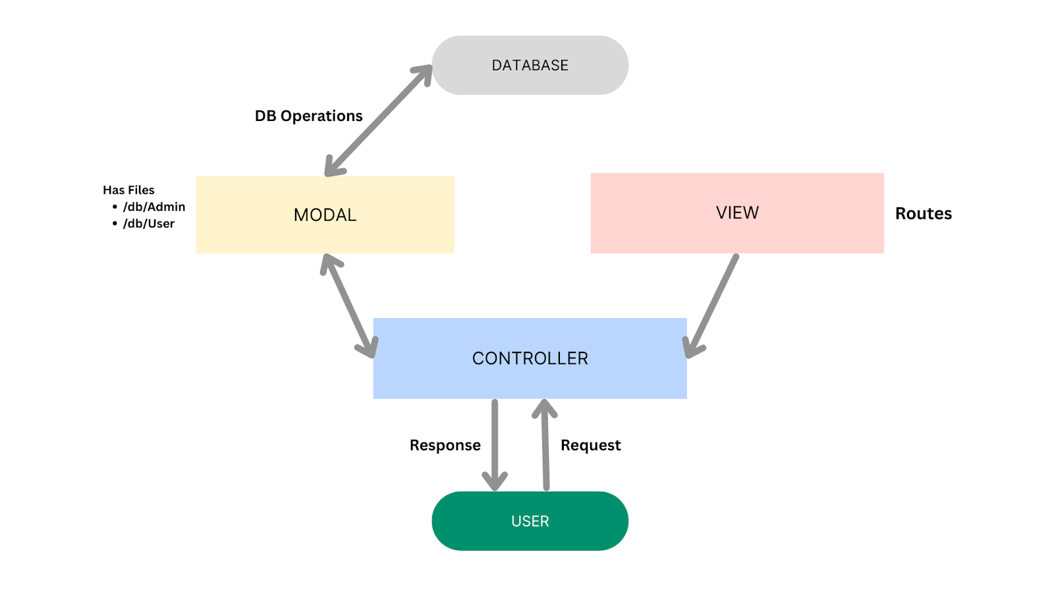

User Stories
User Type | Functional Requirement (Epic) | User Story / Task | Acceptance Criteria | Priority | Release
User | Product Browsing | As a user, I can browse products by category or search by name. | Products are displayed correctly with filters applied. | High | Sprint-1
User | Cart Management | As a user, I can add products to my cart and view them anytime. | Cart updates correctly and retains items. | High | Sprint-1
User | Order Placement | As a user, I can place an order after checkout. | Order is saved and visible in order history. | High | Sprint-1
Seller | Product Management | As a seller, I can add, update, or delete products. | Product changes reflect immediately. | High | Sprint-1
Seller | Inventory Tracking | As a seller, I can track listed products and stock. | Inventory updates correctly. | Medium | Sprint-2
User | Review System | As a user, I can leave reviews after purchasing products. | Reviews appear on product detail pages. | Medium | Sprint-2
Admin | User Management | As an admin, I can manage users and sellers. | Actions are logged and reflected instantly. | High | Sprint-1
Admin | Order Monitoring | As an admin, I can view all orders placed. | Order data is accurate and accessible. | Medium | Sprint-2

Final Outcome
The Data Flow Diagram and User Stories help visualize system interactions and define clear functional requirements for SuperBuy. This ensures:
- Better collaboration among team members
- Smoother development workflow
- Effective feature implementation aligned with user expectations

